**Virtual Key for Your Repositories**

**package** assignmentvirtualkey;

**import** java.io.File;

**import** java.util.Arrays;

**import** java.util.Scanner;

**public** **class** VirtualKeyforYourRepositories {

**public** **static** **void** main(String[] args) {

// **TODO** Auto-generated method stub

Scanner sc=**new** Scanner(System.***in***);

String s="UMA LAKSHMI";

String path="D:/FileHandling/projects";

File f=**new** File(path);

System.***out***.println();

System.***out***.println(" ****************WELCOME TO MY WORLD*******************\n");

System.***out***.println(" *************************HI,THIS IS "+s+" ********************\n");

System.***out***.println(" **************************THIS APPLICATION IS DEVELOPED BY "+s+" **************\n");

System.***out***.println();

System.***out***.println();

System.***out***.println();

f.mkdirs();

**while**(**true**){

System.***out***.println("1.Display the files in ascending order\n");

System.***out***.println("2.Below this are some User Enabled Options to perform the operations \n");

System.***out***.println("3.Terminate Program\n");

System.***out***.println("*****What option do you want to select and perform the operation***** \n");

System.***out***.println();

**int** choice = sc.nextInt();

**switch**(choice)

{

**case** 1:

File arr[] = f.listFiles();

Arrays.*sort*(arr);

**for**(**int** i=0;i<arr.length;i++)

System.***out***.println(arr[i]);

**break**;

**case** 2:

Boolean temp = **true**;

**while**(temp) {

System.***out***.println(" 1 - To Add a file in the existing Directory");

System.***out***.println(" 2 - To Delete a file from the existing Directory. ");

System.***out***.println(" 3 - To Search a user specified file from the Directory");

System.***out***.println(" 4 - Back to the previous menu");

System.***out***.println(" 5 - Terminate Program");

System.***out***.println();

**int** choice2 = sc.nextInt();

**switch** (choice2) {

**case** 1:

System.***out***.println("Enter a file name");

String name = sc.next();

**if**(**new** File(f,name).exists()){

System.***out***.println("file already exist");

}**else** {

File folder1 = **new** File(f, name);

folder1.mkdir();

**if** (**new** File(f, name).exists()) {

System.***out***.println("file "+folder1+" added successfully");

}

}

**break**;

**case** 2:

System.***out***.println("Enter a file name");

String name1 = sc.next();

**boolean** folder2 = **new** File(f, name1).exists();

System.***out***.println(folder2);

**if** (folder2 == **true**) {

File folder3 = **new** File(f, name1);

folder3.delete();

System.***out***.println("File "+folder3+" successfully deleted");

} **else** {

System.***out***.println("file does not exist");

}

/*f2.delete();*/

**break**;

**case** 3:

System.***out***.println("Enter a keyword to search");

String search = sc.next();

File arr1[] = f.listFiles();

**for**(**int** a=0;a<arr1.length;a++){

**if**(arr1[a].getName().startsWith(search)){

System.***out***.println(arr1[a]);

}**else**{

System.***out***.println("No file found");

}

}

**break**;

**case** 4:

temp = **false**;

**break**;

**case** 5:

System.***out***.println("*********Program Terminated Successfully***********");

System.*exit*(0);

**default**:

System.***out***.println("Input correct value and retry");

}

}

**break**;

**case** 3:

System.***out***.println("*********Program Terminated Successfully***********");

System.*exit*(0);

**default**:

System.***out***.println("Input correct value and retry");

**break**;

}

}

}

}

**Algorithm:**

Step1:start the program in eclipse.

Step2:create a folder directory path for adding and creating a files.

Step3:print the welcome screen and developer name.

Step4:display the initial menu and the and take user input.

Step5: switch input value

* Case1 is true display the sorted file,if it present in current working directory and go to the step4.
* Display case2 is true it display the sub menu,user performs the some operation.
* Case3 terminate the program.
* Switch input value
* Case1 is true the user to perform the add and create a file operation and goes to step 5.1 step.

Step5.1:

Case2 is true and allow user to perform deletion operation and goes to the 5.2 and false goes to 5.2.

Step5.2:case3 is true and allow user to perform the operation and goes to the 5.2 and false goes to 5.3.

Step 5.3:case 4 is true and program goes to the main menu option(goes to step4) and false goes to 5.4.

5.4:case5 is true program is terminated and false wrong input goes to the default statement.

5.5:stop the program.

step6:display the output.

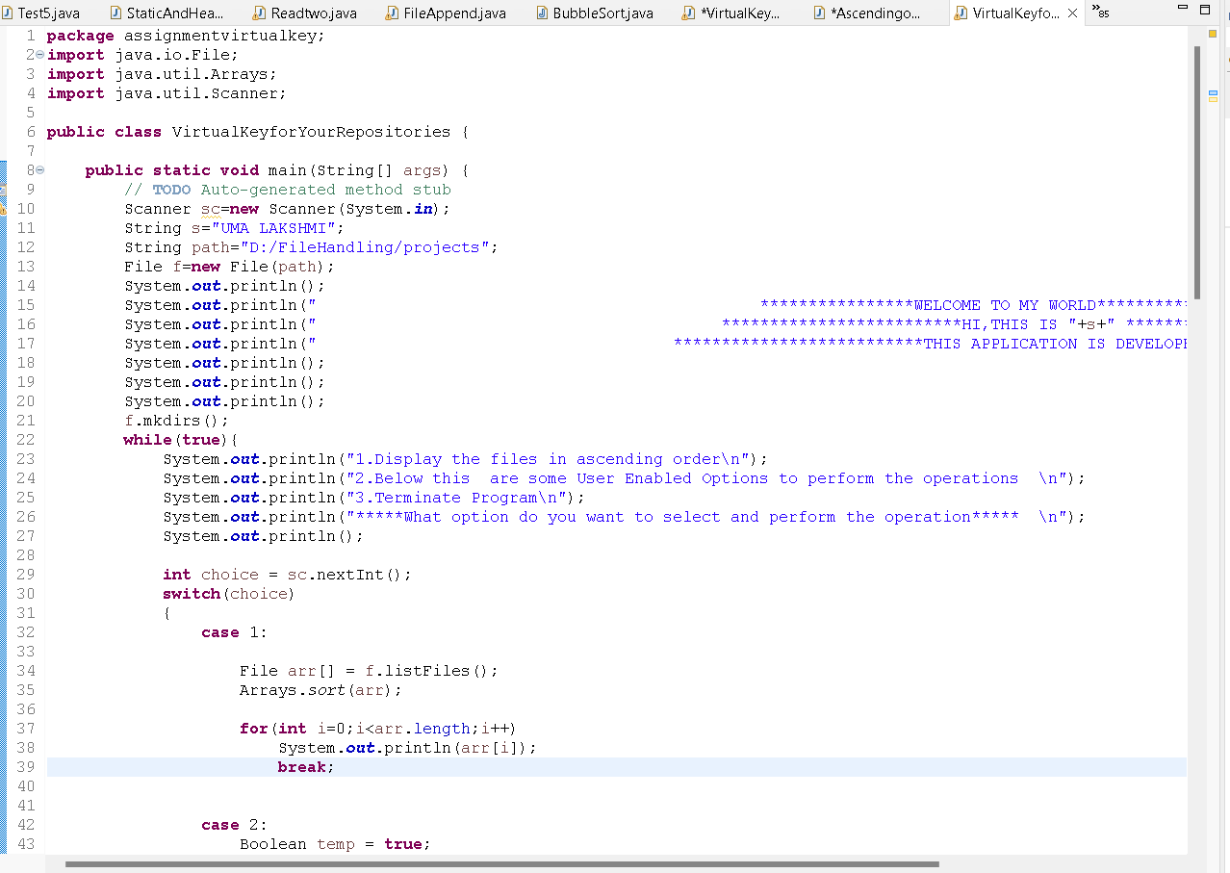

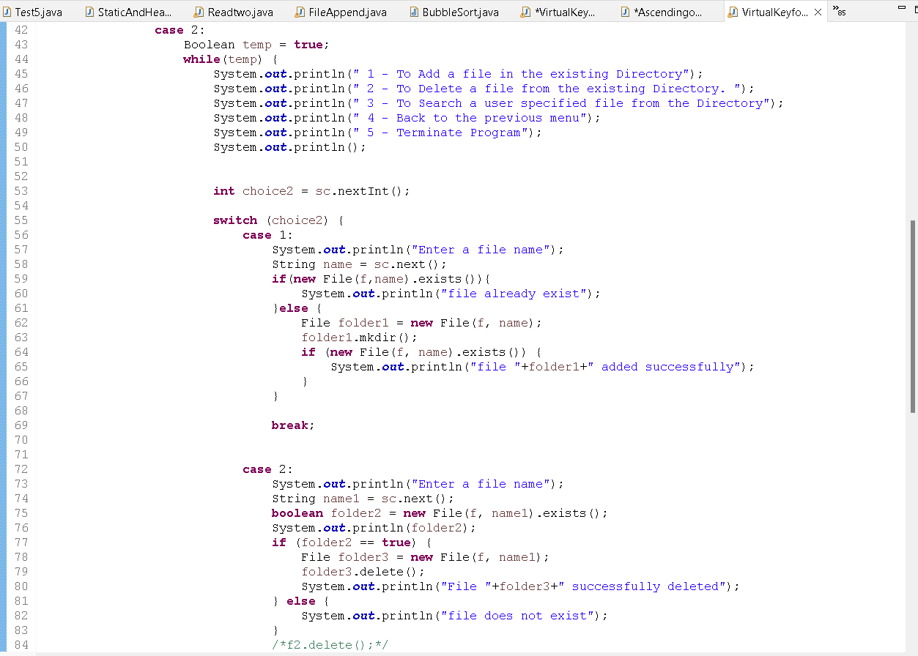

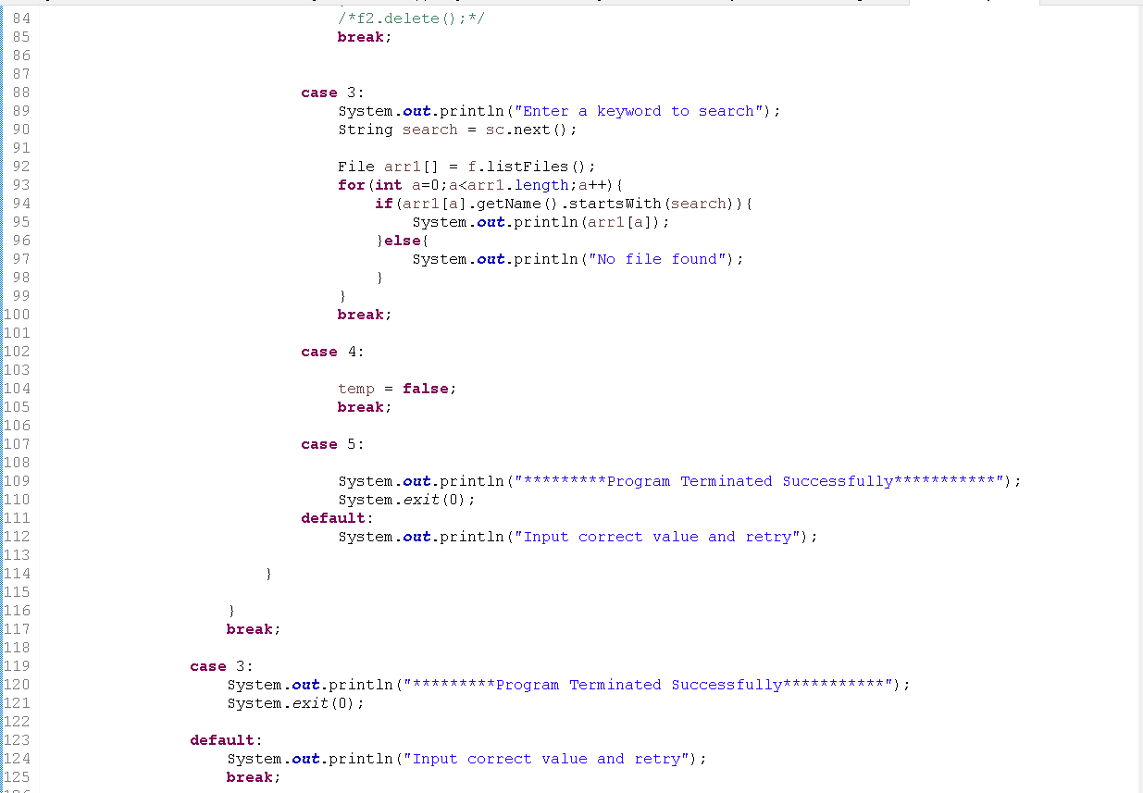

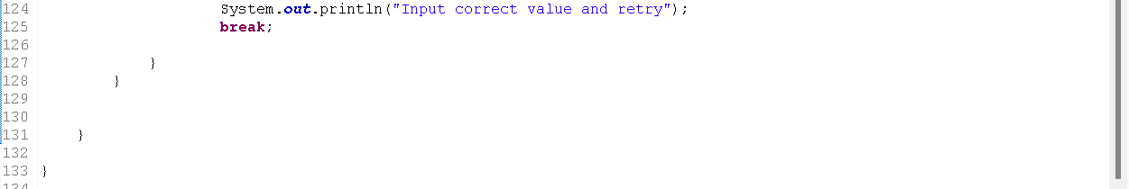

**Folders:**

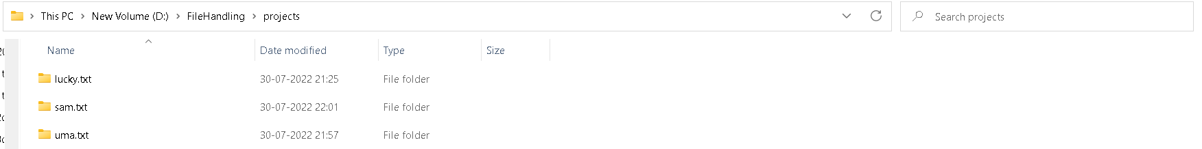

**OUT PUT:**

